**Project Design Phase-II**

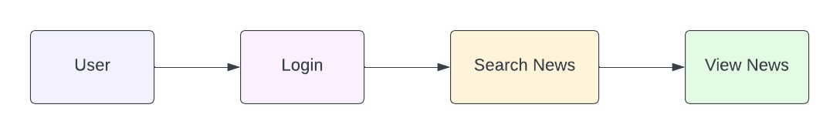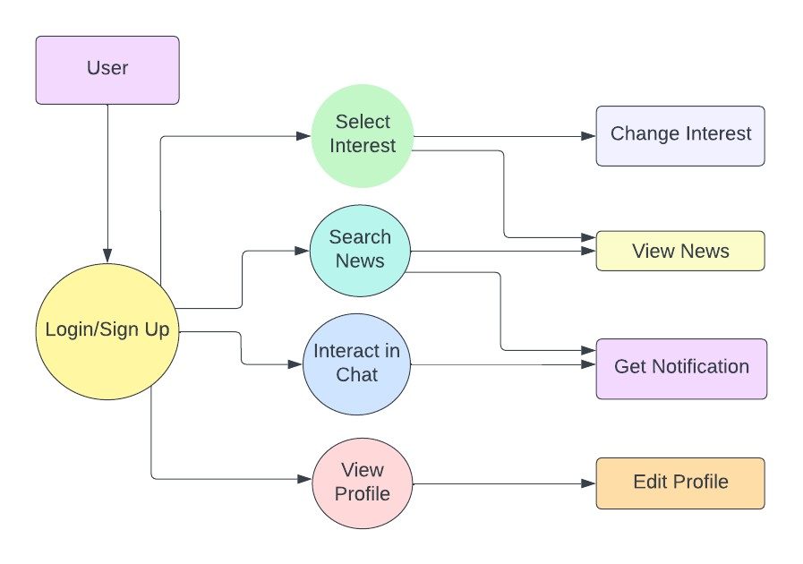**Data Flow Diagram & User Stories**

|  |  |
| --- | --- |
| Date | 03 October 2022 |
| Team ID | PNT2022TMID04471 |
| Project Name | Project - News Tracker Application |
| Maximum Marks | 4 Marks |

**Data Flow Diagrams**

A Data Flow Diagram (DFD) is a traditional visual representation of the information flows within a system. A neat and clear DFD can depict the right amount of the system requirement graphically. It shows how data enters and leaves the system, what changes the information, and where data is stored.

**Flow Chart DFD - News Tracking Application**

**User Stories**

Use the below template to list all the user stories for the product.

|  |  |  |  |  |  |  |
| --- | --- | --- | --- | --- | --- | --- |
| **User Type** | **Functional**  **Requirement**  **(Epic)** | **User Story**  **Number** | **User Story / Task** | **Acceptance criteria** | **Priority** | **Release** |
| Customer  (Mobile user,  Web user) | Registration | USN-1 | As a user, I can register for the application by entering my email, password, and confirming my password. | I can access my account / dashboard | High | Sprint-1 |
|  | Confirmation | USN-2 | As a user, I will receive confirmation email once I have registered for the application | I can receive confirmation email & click confirm | Medium | Sprint-1 |
|  | Login | USN-3 | As a user, I can log into the application by entering email & password | I can access my account / dashboard | High | Sprint-2 |
|  | Dashboard | USN-4 | As a user, I can search NEWS and a quick snap is displayed in the dashboard | I can view the NEWS | High | Sprint-2 |
|  | Chatbot | USN-5 | As a user, I can Chart with the bot so that my questions are clarified | I can access the chat | High | Sprint-3 |
|  | Profile | USN-6 | As a user I can edit my interest so that I can get news accordingly | I can access Profile | High | Sprint-3 |
|  | Notification | USN-7 | As a user, I will receive notification to my email so that I’ll be updated on the news | I can receive notification mail | Medium | Sprint-4 |